Jenkins:

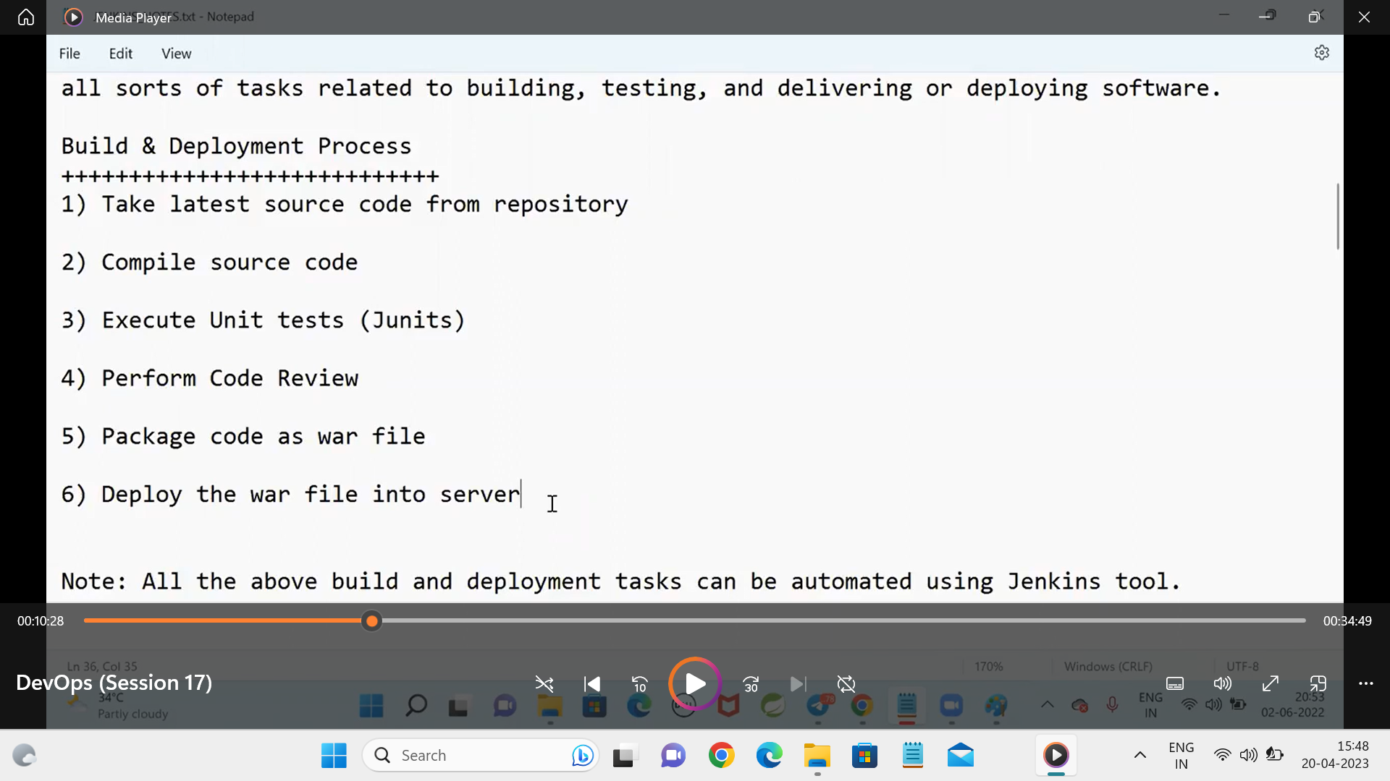

Step-1:

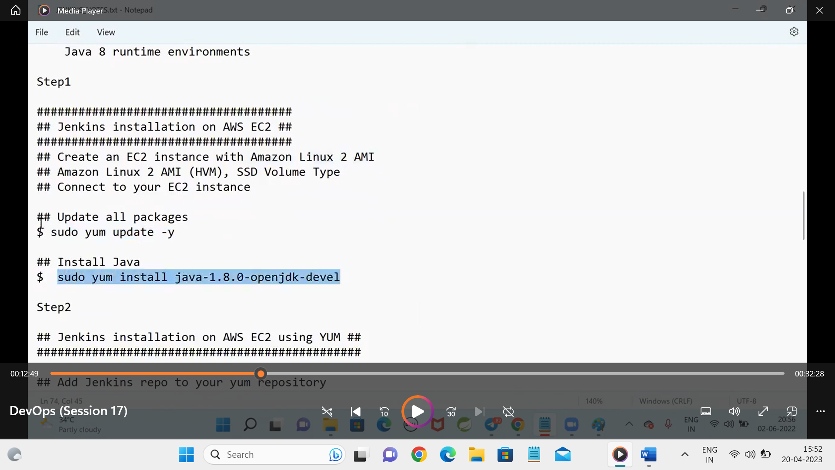

Step -2:

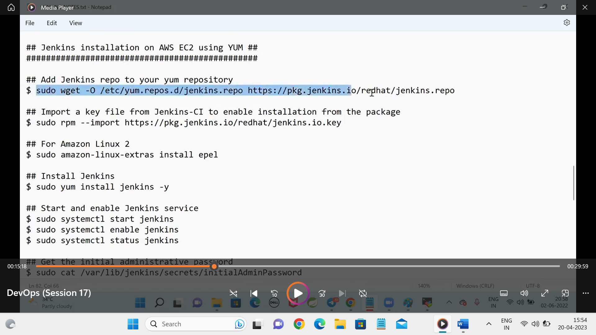

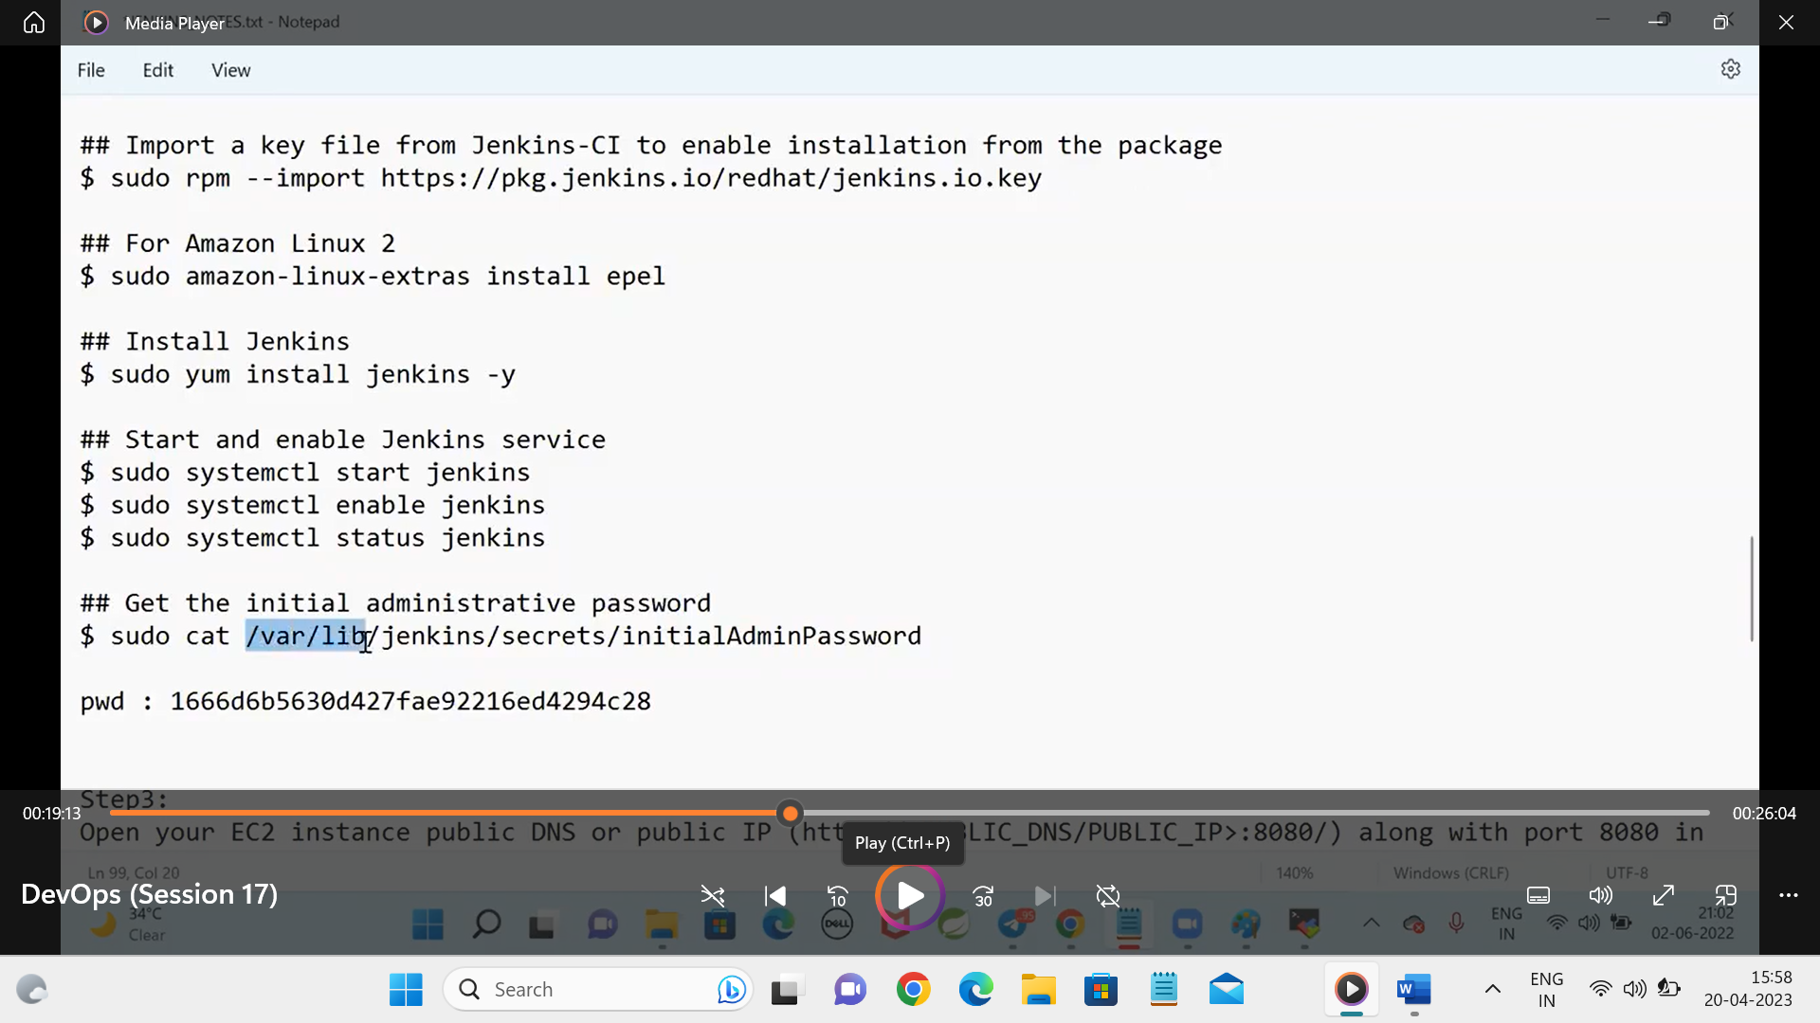

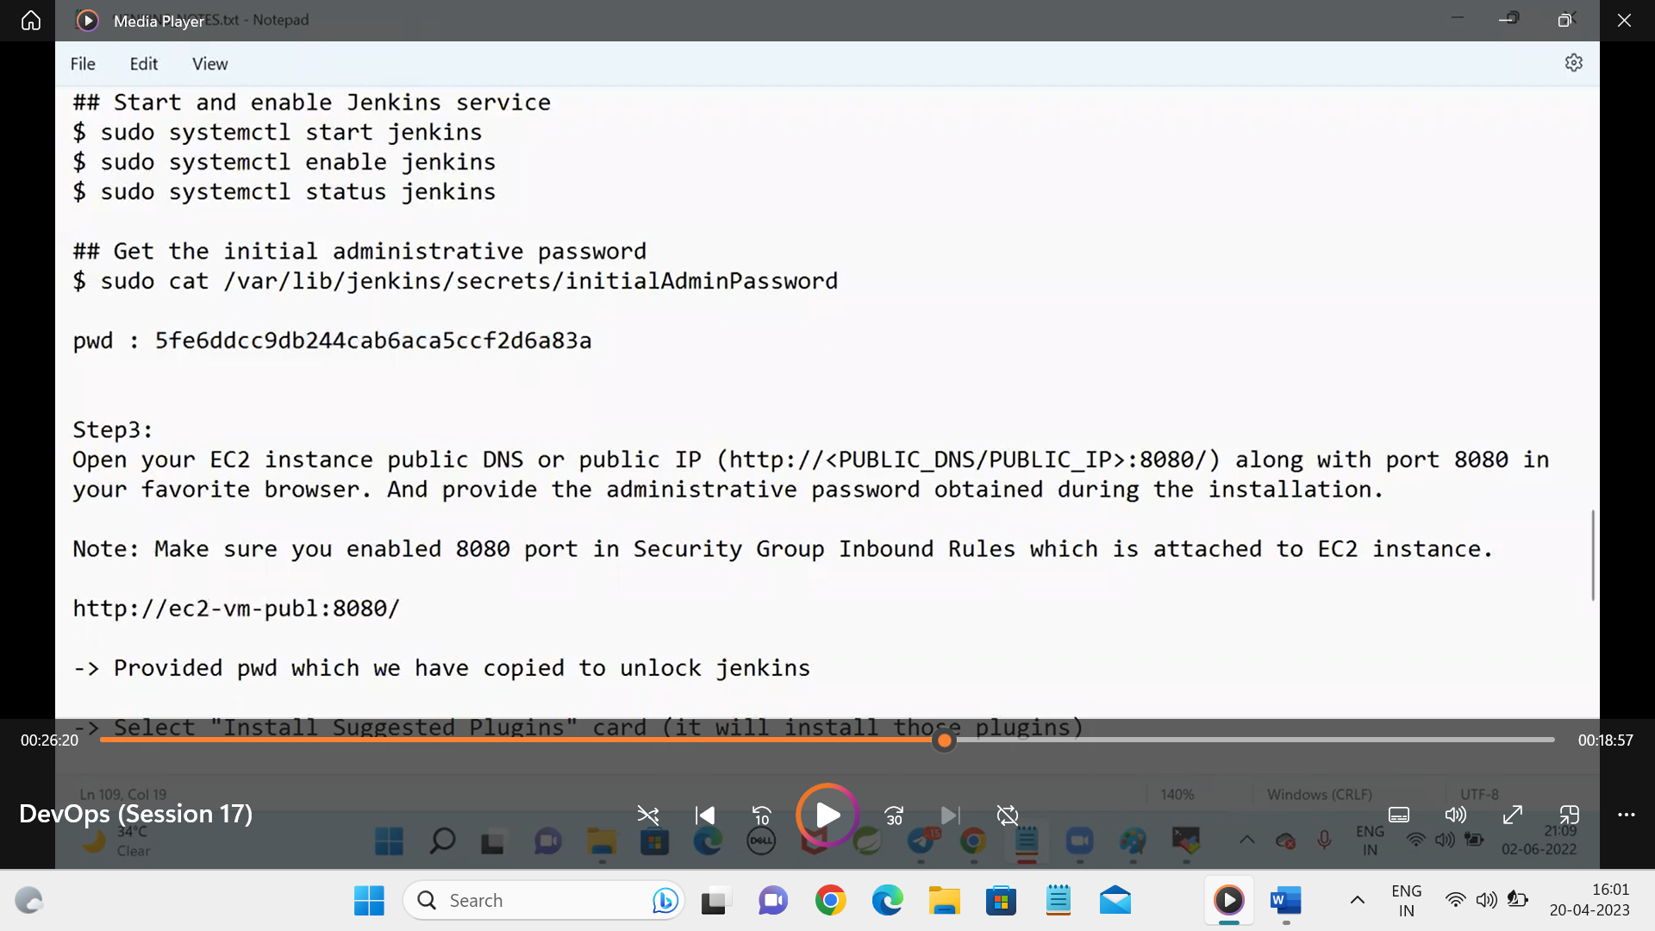

<https://www.linkedin.com/pulse/using-user-data-script-jenkins-installation-aws-ec2-linux-shah?trk=articles_directory> --linkto install Jenkins in aws

b9eac02a6c5b4bdda382e93eb87314a8 –passkey for initial admin setup

in the above installing we must use the linux ami 2 only

then also the key is not working for the above we have to change the key as below

sudo rpm --import https://pkg.jenkins.io/redhat-stable/jenkins.io-2023.key

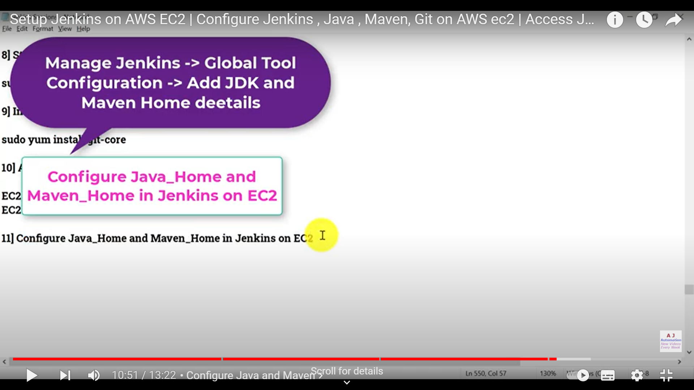

When we are running the java and maven in the Jenkins we are getting the error so we have to install them in the vm and configure the java_home

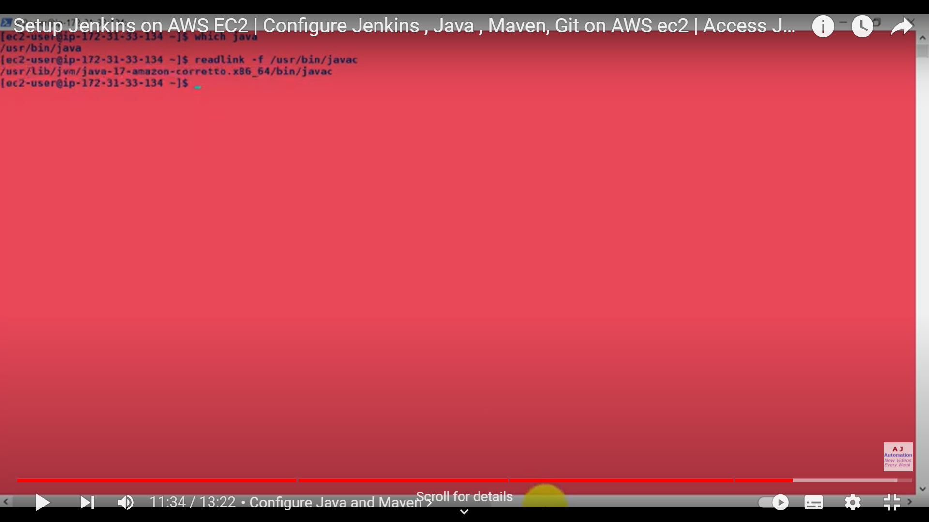

Install java in vm and set path using the

$ sudo update-alternatives --config java

We can find the path of java and give in the jenkins